May Newsletter 2023

As we approach the final few weeks of this academic year, we are delighted that our school continues to be a hive of learning, fun activity and friendship. The children continue to work hard and do their individual best!

Calendar 2023-24
The school calendar for the year 2023-24 is available on Aladdin.

Reports
School reports will be emailed using our Aladdin system on the 19th June 2023. Please ensure your email details are up to date. Standardised test scores will be recorded on reports. It is important to remember that these are a snapshot of one day. Your class teacher will advise on school reports if the score is an accurate reflection of true ability. Each year, the standardised test results reinforce the huge importance we place on listening to your child read and reading to your child as often as possible.

Good Weather
Children are permitted to wear navy plain shorts to the knee and the blue polo shirt in June if the weather is good. We ask parents to send in plenty of drinks for the same.

Homework
There will be no written homework in June. Children may be given reading, spellings and tables for homework.

6th Class Graduation
The 6th Class Graduation date this year will take place on the evening of Wednesday 21st June @7pm.

Well-Being Week
We had a very successful Well-Being Week here at St. Joseph’s, Mulhussey. Gratefulness jars, yoga, stories about dealing with anxiety, daily positive affirmations, mindfulness colouring and a whole school wellness walk were just some of the wonderful activities that the children did. Well done to all involved especially Ms. Kearns and Ms. Farnan for organising it.

Defibrillator
The code for access to the defibrillator located at the school as C123.

Parents Association Family Fun Day
The PA are hosting a Family Fun Run and Fun Day on Sunday 18th June. Volunteers are needed to set up and for helping out on the day.

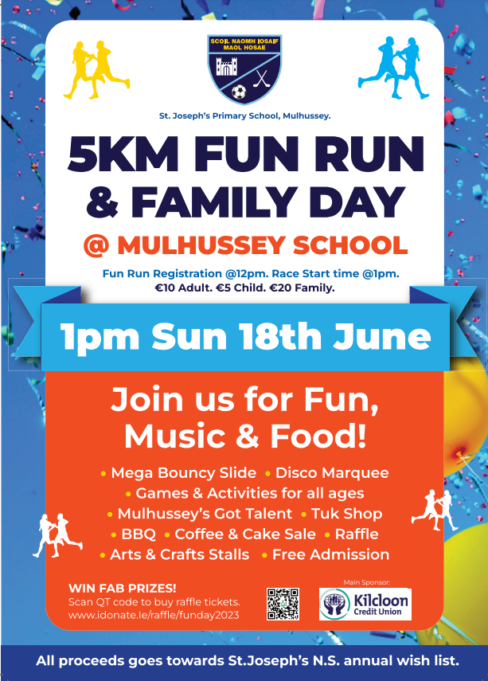

Dates for Your Diary
Junior Infants 2023-24 Induction 7th June
Blackhall Gaels Blitz 3rd & 4th Class GAA grounds, Batterstown 9th June
School Tour for Junior Classes Monday 12th June
School Tour for Senior Classes Wednesday 14th June
PA Fun Day 18th June
Active Week 19th – 23rd June
Sports Day 23rd June (on school grounds)
Friday 30th June Summer Holidays: finish @12pm
Summer Inclusion Programme 3rd -7th July and 21st – 25th of August

:

